**ER Diagram :**

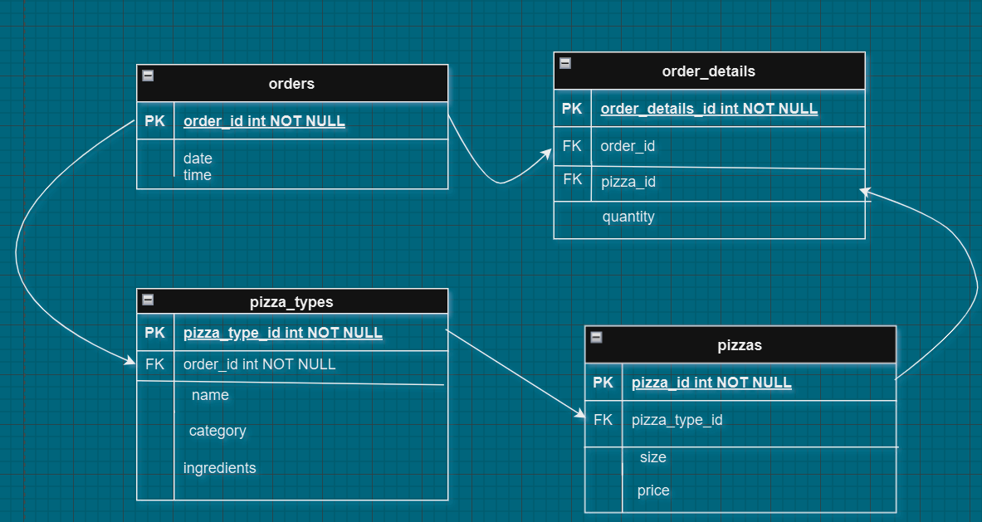

**SQL QUERIES**

**Basic:**

1. Retrieve the total number of orders placed.

select count(order_id) as total_sales from orders;

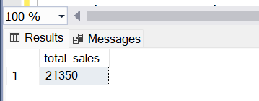

1. Calculate the total revenue generated from pizza sales.

select round(sum(o.quantity*p.price),2) as total_sales

from

order_details o join pizzas p on o.pizza_id = p.pizza_id;

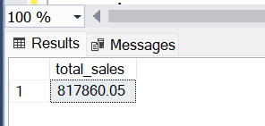

1. Identify the highest-priced pizza.

SELECT TOP 1 pt.name, round(p.price,2) as price

FROM pizza_types pt

JOIN pizzas p ON pt.pizza_type_id = p.pizza_type_id

ORDER BY p.price DESC;

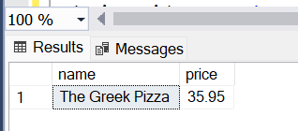

1. Identify the most common pizza size ordered.

select p.size, count(od.order_details_id) as order_count

from pizzas p join order_details od on

p.pizza_id = od.pizza_id group by p.size order by

order_count desc;

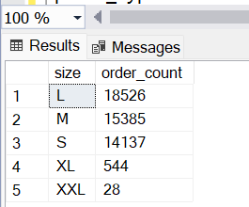

OR

select top 1 p.size, count(od.order_details_id) as

order_count from pizzas p join order_details od

on p.pizza_id = od.pizza_id

group by p.size order by order_count desc;

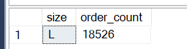

1. List the top 5 most ordered pizza types along with their quantities.

select top 5 pizza_types.name, sum(order_details.quantity)

as quantity from pizza_types

join

pizzas on pizza_types.pizza_type_id = pizzas.pizza_type_id

join

order_details on order_details.pizza_id = pizzas.pizza_id

group by pizza_types.name

order by quantity desc;

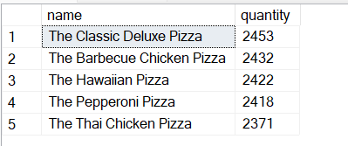

**Intermediate :**

1. Join the necessary tables to find the total quantity of each pizza category ordered.

select pizza_types.category, sum(order_details.quantity)

as quantity from pizza_types

join pizzas on

pizza_types.pizza_type_id = pizzas.pizza_type_id

join order_details on order_details.pizza_id = pizzas.pizza_id

group by pizza_types.category order by quantity desc;

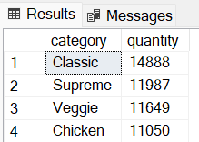

1. Determine the distribution of orders by hour of the day.

SELECT DATEPART(HOUR, time) as hour, count(order_id) as

order_count FROM orders group by DATEPART(HOUR, time)

order by DATEPART(HOUR, time);

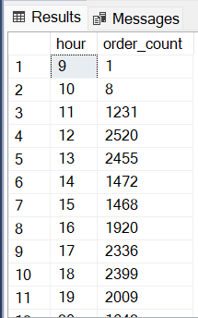

1. Join relevant tables to find the category-wise distribution of pizzas.

select category, count(name) as count from pizza_types

group by category;

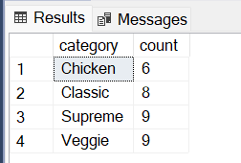

1. Group the orders by date and calculate the average number of pizzas ordered per day.

select avg(quantity) as avg_order_per_day from

(select orders.date, sum(order_details.quantity) as quantity

From orders

join order_details on orders.order_id = order_details.order_id

group by orders.date) as order_quantity ;

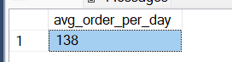

1. Determine the top 3 most ordered pizza types based on revenue.

select top 3 pizza_types.name, sum(order_details.quantity*pizzas.price) as revenue from

pizza_types join pizzas on

pizza_types.pizza_type_id = pizzas.pizza_type_id

join order_details on order_details.pizza_id = pizzas.pizza_id

group by pizza_types.name order by revenue desc;

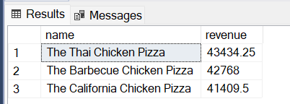

**Advanced:**

1. Calculate the percentage contribution of each pizza type to total revenue.

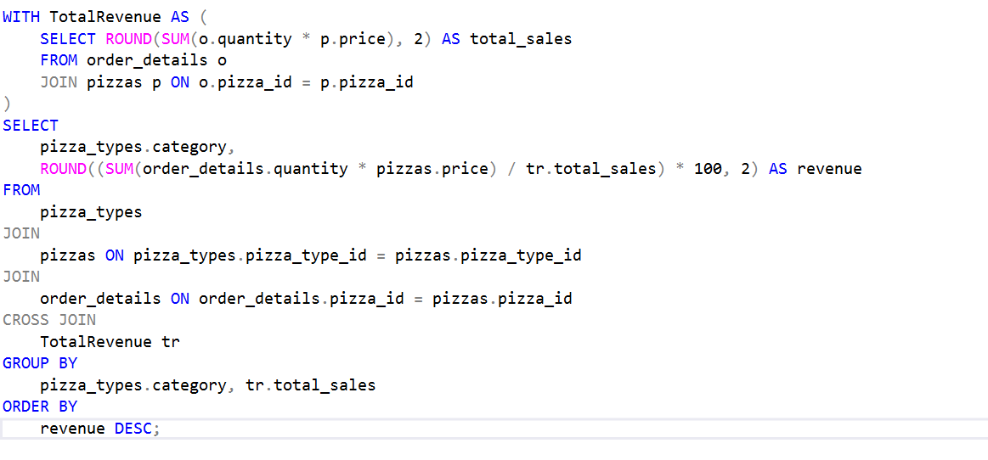

OR

select pizza_types.category,

round((sum(order_details.quantity*pizzas.price) /

(select round(sum(o.quantity*p.price),2) as total_sales

from order_details o join pizzas p on

o.pizza_id = p.pizza_id))*100,2)

as revenue from

pizza_types join pizzas on

pizza_types.pizza_type_id = pizzas.pizza_type_id

join order_details on order_details.pizza_id = pizzas.pizza_id

group by pizza_types.category order by revenue desc;

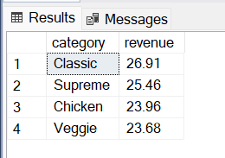

1. Analyze the cumulative revenue generated over time.

select date, round(sum(revenue) over (order by date),2)

as cumulative_revenue from

(select orders.date, sum(order_details.quantity*pizzas.price)

as revenue from order_details join pizzas on

order_details.pizza_id = pizzas.pizza_id join orders

on orders.order_id = order_details.order_id

group by orders.date) as sales;

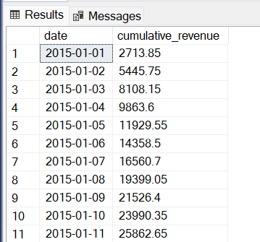

1. Determine the top 3 most ordered pizza types based on revenue for each pizza category.

select category, name, revenue from

(select category, name, revenue, rank() over(partition by category order

by revenue desc ) as rn from

(select pizza_types.category, pizza_types.name, sum(order_details.quantity*pizzas.price) as revenue from

pizza_types join pizzas on pizza_types.pizza_type_id = pizzas.pizza_type_id

join order_details on order_details.pizza_id = pizzas.pizza_id

group by pizza_types.category, pizza_types.name) as a) as b

where rn <= 3 ;

